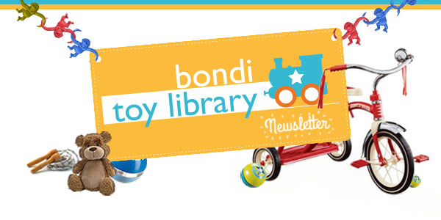

Welcome
Another year is almost at an end, and Bondi Toy Library (BTL) would like to wish everyone a very Merry Christmas. It's been a big year, with a mass tidy up, new toys, and a 30th birthday celebration.
We are looking forward to an even bigger and better 2014 with a revamped space thanks to a State Government grant, even more toys, a calendar of educational talks, a few surprises at the beginning of the year... and a party to say thank you to all for supporting such a worthwhile organisation!
Special thanks goes out to Waverley Council for their enduring support, but also to our fabulous volunteers, staff, Committee members, generous toy donators (Modern Teaching Aids, Lisa Sherrard). Without any of these people and organisations, the BTL could not go on!
BTL will be closing Saturday 21 December, until 28 January 2014. So until doors open, enjoy the Silly Season and some good quality summer time with your families.
The team at Bondi Toy Library

Tell Us What You Want
Bondi and the surrounding areas are experiencing a baby boom, plus a dramatic change in lifestyles, household types and parental roles. At the same time, we all have increased awareness of the pro-environmental values of re-use, recycle and the need to reduce consumerism (especially of cheap toys). Toy Libraries embed all these values as well as showing children the value of sharing.
As part of our plans to grow our membership and provide a better service, we need to know what you want, how you want it, and when you want it! It would really help us if you could please complete our simple survey. We promise it will take no more than two minutes of your time!
Take survey now

Miss Paulette Column
Our very own resident educational guru, Paulette, is a Teacher and Educational Advisor who has worked with schools and teachers around the globe.
The festive season is upon us and it provides an ideal context to discuss Communication, a key area in children's development. Communication does not consist only of words, sentences and stories: it includes the language of images, art, dance, drama, movement, rhythm and music. Many of us use the holiday season to make contact with loved ones. Try to involve your children in this communication this year.
My number one suggestion is to set up a Christmas writing table. Keep pens, felts, crayons, pencils and paper on it. Add Christmas cards, gift tags, wrapping paper, Christmas cut outs etc. Ask your child whom they would like to communicate with.
Write Christmas emails/cards/pictures to relatives together. Model writing and drawing. Encourage children to draw or make marks on paper and follow through by asking them to 'read' it back to you. Write their story underneath their work. Posting to loved ones or displaying the work shows that you value it, and it has a purpose.
Finally, a great tip for Christmas shopping. In the early years, the more a toy does by itself, the less a child uses his or her imagination. Keep it simple this Christmas and happy holidays to you all.

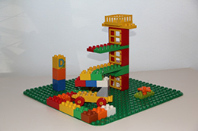  Toy of the Week:  Lego  Lego is a great traditional toy that is enjoyed amongst a wide age range, and has been educating children for generations. Lego is a popular construction toy, as it has endless possibilities. I particularly like Lego because it is an open-ended activity that allows for free play, and children can use it independently or work together.  Motivate your child by asking them what they would like to create, then help them get started. Ask them to pass you pieces using education language such as "I need a red brick, can you help me find one?" or "How many wheels will we need?". Thinking, problem solving and concentration are great skills you are encouraging. Work together for a while then leave them to work independently. Take photos of the creations and make your own Lego book, or display them for a few days. | Free Messy Fun!  BTL Annual Party  Dress for mess and get ready for a messy good time. You and your children are invited to Bondi Toy Library's first ever MESSY PLAY DAY. Come along and enjoy a variety of crafts with your children, activities including hand painting, feet painting, glitter, glue and spray bottle painting. Get as messy as you like!  PLUS, the very fabulous Lah Lah's Live Band, colouring competition, raffle, sausage sizzle, cake, yummy fruit, music and much more! All the fun and no mess to clean up!  Saturday 1 March, 2014, 10am - 12pm, Bondi venue TBC.  Registry via Eventbrite is essential. To register, please click here.

To learn more about the Bondi Toy Library,
visit www.bonditoylibrary.com
unsubscribe from this list | update subscription preferences

